Modeling Human Fear of Risk

When making a financial decision mired in risk, how well do humans generally fare? Are they inclined to make the mathematically optimal choice? How strongly do people consider the value of what they stand to gain compared to what they currently have? To what extent do they alter their decision making in the face of much higher expected benefit? This study aims to take a modest look into questions like these with a simple game.

*The Game*

Subjects were given the following cover story:

While taking a break from studying for finals, you run into your friendly neighborhood millionaire, who tells you he is feeling generous. He proposes to select a number uniformly at random from 1 to 11, inclusive (in other words, he has a 1/11 chance of choosing any number in that range). He will keep this number secret. He then hands you a table bell to ring. He states that if you ring the bell a certain number of times $x$, he will give you $x$ hundred dollars as long as $x$ is strictly less than the number he has chosen. The money he gives you accumulates: for example, say he secretly chose the number 4. If you ring the bell once, he gives you 100 dollars. If you ring the bell once more, he will give you 200 more dollars, as you rang the bell 2 times in total. You will thus have 300 dollars after 2 rings. If you ring once more, he gives you 300 dollars, for a total of 600 dollars.

“The obvious catch,” he says slyly, “is that if you ring the bell the same number of times as the number I choose, I take back everything I give you and the game ends, never to be played again."

For whatever reason, you trust that he will not change his number behind your back and that he will stay true to his word on your earnings. How many times would you ring the bell? Try your best to not let morals factor into this decision-treat it as a friendly game. For convenience, the total potential earnings for each ring amount is given (Note: in the form subjects filled out, the following table is simply a 10-part multiple choice response with the total potential earnings stated next to the amount of rings):

Table 1. Total earnings from the millionaire for each successful bell ring amount.

|  |  |  |  |  |  |  |  |  |  |  |
| --- | --- | --- | --- | --- | --- | --- | --- | --- | --- | --- |
| Successful Rings | 1 | 2 | 3 | 4 | 5 | 6 | 7 | 8 | 9 | 10 |
| Total Money Earned | $100 | $300 | $600 | $1000 | $1500 | $2100 | $2800 | $3600 | $4500 | $5500 |

With a follow-up question, subjects were asked to consider this scenario again, but with an alternate earning function: instead of an accumulating function based on a fixed incremental gain, subjects would triple their current earnings for every successful ring made after the first (the first ring, if successful, remains earning them $100). Thus after $x$ rings, the subjects earn $100*3^{x-1}$ dollars. In the cover story, the host was now described as a billionaire. Subjects were again provided a multiple choice response, this time characterized by the following table:

Table 2. Total earnings from the billionaire for each successful bell ring amount.

|  |  |  |  |  |  |  |  |  |  |  |
| --- | --- | --- | --- | --- | --- | --- | --- | --- | --- | --- |
| Successful Rings | 1 | 2 | 3 | 4 | 5 | 6 | 7 | 8 | 9 | 10 |
| Total Money Earned | $100 | $300 | $900 | $2700 | $8100 | $24300 | $72900 | $218700 | $656100 | $1968300 |

The reason the earnings were tripled in the follow-up question (as opposed to something more natural, like doubling) was to ensure subjects stood to earn at least as much in the second part as the money earned in the first part for the same number of rings. This observation was explicitly pointed out to all subjects to discourage them from providing a smaller answer than in the previous part, which wouldn’t make sense.

*The “Optimal” Choice*

The survey I conducted stated on the outset that there were no “right” or “wrong” answers to the questions, and that it should take less than 3 minutes. This was done simply to encourage people not to do any math and instead to speak on what they would actually do from an intuitive perspective. There is some form of an “optimal” choice for both parts, of course. To see this, consider a remodeling of the problem: what if instead of ringing the bell again and again, you simply tell the questioner the number of times, $i$, you plan to ring- in effect handing him a certificate that says “If your secret number, $Z$, is greater than $i$, give me what you promised, else leave me alone?” For the millionaire, you either get $100*\frac{i(i+1)}{2}$ dollars with probability $P\left(Z>i\right)=(1-\frac{i}{11})$, or you get nothing. The same applies with the billionaire, with $100*3^{i-1}$ being your potential earnings. All one has to do now is find the integer value $i'$ that maximizes your expected earnings, which can be done with differentiation. For the millionaire, the result is $i^{'}=7$. For the billionaire, the answer is simply 10, as the money you are earning grows much faster than the rate at which $P\left(Z>i\right)$ decreases. So the “correct” answers in this survey are $i^{'}=7$ and $i^{'}=10$. I put “correct” in quotes because these values maximize what you earn *when averaging over* *many trials*. With users only having one chance to play the game (“…the game ends, never to be played again."), how are they inclined to react? Do they actually ring 7 times for the millionaire, with only a 4/11 chance at winning $2800? Or do they “play it safer” and ring less, perhaps even only once to maximize the chances that they win at least *something?*

*The Models*

With this setup, I present a series of probabilistic models and discuss how well they fit the responses I received, as well as illustrate how lucrative they are in the end of the report. The first three models are very basic, and meant merely to compare as benchmarks with the next, which is a little more involved.

Before going over each model, I define some variables. Let $n$ denote the number of trials run for each model in determining how lucrative they are. Let $i$ and $Z$ continue to denote the number of times one rings the bell and a random variable signifying the secretly chosen number, respectively. As mentioned, $Z$ has a uniform probability density function: $P\left(Z=i\right)=\frac{1}{11}$ for all $i$ in [1, 11], and $P\left(Z>i\right)=(1-\frac{i}{11})$ for all i in [0, 11]. Let $p_{i}$ denote the probability that a model rings the bell an $i^{th}$ time given that it successfully rang the bell $i-1$ times. Defining $p_{i}$ as a conditional probability allows probabilities to be chain multiplied conveniently. We define $p_{1}=1$ for all models. The rationale for this is that all models (and subjects) begin by ringing the bell 0 times and risk nothing in ringing the bell once more. This works nicely, as at the start the subject has nothing to lose and everything to gain, so they should always ring the bell at least once (indeed, in my forms I did not allow for a 0 ring option). Thus, all models start by considering $p_{2}$, the probability of ringing a second time given that the first ring was successful. On the other hand, $p_{11}$ is defined to be 0, as the subject has already earned the highest amount possible with 10 successful rings, meaning the next ring will ensure he or she loses everything (thus, I did not allow for subjects to ring 11 times in my answer choices). The progression of $p_{i}$ values is what varies throughout my models- they act as the definition of a model in this paper. Given a model, the probability that it rings the bell exactly $I$ times is calculated by performing the multiplication $p_{2}*p_{3}*…*p_{I}*(1-p_{I+1})$, because to ring $I$ times, the model must have decided to continue ringing all the way up to the point when it decided not to ring $I+1$ times. In determining how lucrative a model is, it is assumed that the result of each individual trial of any model is independent of the results of any other trial.

One very important point. The calculation described above for determining the probability a model rings the bell a certain number of times may seem overly simplistic, as it does not factor in the secretly chosen number $Z$ at all. To explain, there is a difference between determining the probability a model rings the bell some number of times and determining how lucrative a model is. Indeed, $Z$ is used (and trials are run) only for the latter task, whereas the former is achieved by appropriate multiplication of the model’s relevant $p_{i}$ values. The reason for this is that models, just like subjects, have no knowledge of what the secretly chosen number is. The primary purpose of these models is to describe what human responses to the game might look like, therefore when calculating the probability a model would ring the bell some number of times, it is actually assumed that, once a ring is made, it is successful, and thus that the game ends only when the model decides to stop ringing (or if it rang 10 times), analogous to how the survey I conducted ends when a subject settles on his or her final answers.

With these parameters set, I discuss the first 3 basic models.

*Model 0 (M0) – Ring 10 times*

Playing it safe is probably the most natural instinct. Yet I expect a good deal of subjects to ponder the question “is this really a survey asking merely what I would do? Or is this a quiz and is there a mathematically correct answer?” What if, along this line of thinking, a player reasons, “as long as I have no control over $Z$, there is little point in playing it safe when, should I resolve to ring 10 times, my expected earnings are 5500*1/11 and 1968300*1/11? These are the highest values of all rings by default, as the probability $Z$ is 11 remains constant at 1/11 while the earnings rise with each ring.” This is flawed thinking as the player disregards the higher success rates at lower rings, but there were a few responses of 10 for the first part, so perhaps this might be what these subjects were thinking (of course, 10 is the “correct” answer for the billionaire, which is likely a reason why it was a lot more common in the second part of the game than the first).

*Model 1 (M1) – Flip a Coin*

Although this model performs worst (in terms of money earned) in simulations for both parts among the models given, it introduces the idea of decay: players are less likely to stay playing for longer periods of time. Simply flip a fair coin at each step to decide whether to ring the bell again: $p_{i}=\frac{1}{2}$ for 1 < $i$ < 11. Consequently, the model would ring at least twice half the time, at least three times a quarter of the time, and so on. This model does not consider how much money it already won nor how much it stands to gain specifically for the $i^{th}$ ring. The model only considers the probability distribution of $Z$ as a matter of due course: the probabilities of ringing higher amounts of times are less than those of lower amounts of times, but only due to the fact that 0 < $p_{i}$ < 1 for all $i$, not because $p_{i}$ reduces as $i$ increases. The choice of a fair coin is arbitrary. With this model, the probability that the bell is rung *exactly $i$*  times is $\frac{1}{2^{i}}$ for all $i$ values in [1, 9]. For $i$ = 10, it is $\frac{1}{2^{9}}$. To explain, ringing exactly $i$ times means a coin was flipped to decide whether to ring $i+1$ times and it was decided not to, and this occurs with probability $1-p_{i+1}=\frac{1}{2}$. The probability that a model even had this chance to flip is equal to the probability of flipping to ring $i-1$ times (1 time for each value from 2 to $i$, inclusive), and this occurs with probability $\frac{1}{2^{i-1}}$ (it is assumed here that the result of a flip is independent of previous flips). Multiplying $\frac{1}{2^{i-1}}$ by $\frac{1}{2}$ yields $\frac{1}{2^{i}}$, however we don’t multiply them when $i$ = 10 because the probability that we ring after 10 is 0, not $\frac{1}{2}$, and multiplying by (1 – 0) = 1 leaves the original $\frac{1}{2^{i-1}}$ factor unchanged, yielding $\frac{1}{2^{9}}$ for $i$ = 10.

*Model 2 (M2) – Conditional Thinking*

This model considers the probability density function for $Z$ more thoughtfully, but still does not factor money earned. Given that a subject has successfully rung 1 time, he or she may be inclined to believe that the probability of another successful ring “adjusts” in the Bayesian sense: in other words, because without any information one could say that $P\left(Z>2 | Z>1\right)=\frac{P(Z>2)}{P(Z>1)}=\frac{\frac{9}{11}}{\frac{10}{11}}=\frac{9}{10}$, the subject may reason he has a $\frac{9}{10}$ shot at winning another 200 more dollars. More generally, let some dummy variable $i'$ denote the previous ring number, $i-1$. Then the subject may have the intuition that $P\left(Z>i | Z>i'\right)=\frac{P(Z>i)}{P(Z>i')}=\frac{\frac{11-i}{11}}{\frac{11-i'}{11}}=\frac{11-i}{11-i'}$ holds. This model runs with that intuition and sets $p_{i}=\frac{11-i}{11-i'}=\frac{11-i}{11-(i-1)}=\frac{11-i}{12-i}$ for 1 < $i$ < 11. For example, if the model rang $i'$ = 3 times successfully so far, the model will ring again with probability 7/8. What’s interesting about this model is that, due to telescoping products, each number of rings occurs with probability 1/10. To illustrate, note again that ringing exactly $i$ times means deciding not to ring the $i$ + 1st time, which occurs with probability $1-p_{i+1}=1-\frac{11-(i+1)}{12-(i+1)}=\frac{(12-(i+1))-\left(11-(i+1)\right)}{12-(i+1)}=\frac{1}{11-i}$. Again, the probability a model gets to this point is equal to the probability of flipping for the 2nd ring through to and including the $i^{th}$ ring. Setting up the conditional probabilities $p_{i}$ for multiplying, we have $p_{2}*p_{3}*p_{4}*…*p_{i}=\frac{9}{10}*\frac{8}{9}*\frac{7}{8}*…*\frac{11-i}{12-i}=\frac{11-i}{10}$ (via the telescoping products). Now it is clear that multiplying this result with the probability of deciding not to ring an ( $i$ + 1)st time yields $\frac{11-i}{10}*\frac{1}{11-i}=\frac{1}{10}$. Thus, the probability that the bell is rung *exactly $i$* times is 1/10 for any $i$ in [1, 10].

*A More Sophisticated Model*

It’s unlikely that humans would leave this game to chance when money is on the line, and I don’t believe humans are equally likely to pick any of the 10 options allowed. So how might responses be distributed?

*Logical Relationships Between pi and Relevant Parameters*

To start, let’s establish some logical relationships between $p_{i}$ and various relevant parameters. First consider the probability that the secret number is greater than $i$, $P(Z>i)$. As $i$ grows, $P(Z>i)$*decreases.* Thus, if other factors remained the same, we would like for $p_{i}$ to decrease as well, meaning $p_{i}$ should have a direct relationship with $P(Z>i)$. Next, consider the amount of money offered for ringing an $i^{th}$ time *by the millionaire.* For all $i$, this is just $100*i$, a growing function. Thus, if other factors remained the same, we would like for $p_{i}$ to grow as $i$ grows, meaning $p_{i}$ should have a direct relationship with the amount of money offered for the $i^{th}$ ring. Coincidentally, multiplying $P(Z>i)$ by $100*i$ yields a useful quantity: the expected value of money stood to gain for ringing an $i^{th}$ time. Let $E[i]$ denote this value. Wanting $p_{i}$ to have a direct relationship with both $P(Z>i)$ and $100*i$ implies wanting a direct relationship with $E[i]$. $E[i]$ can therefore be considered a measure of utility that we can pass into some modeling function $f$ to get our desired value $p_{i}$.

*Desired Properties of a Modeling Function*

Now, let’s consider some desired properties of $f$, the function to pass $E[i]$ into in order to obtain a suitable $p_{i}$. Obviously, such a function should always output values in the range [0, 1], as probabilities can never be outside of this interval. As $E[i]$ approaches 0, we would like our function’s output to approach 0, and as $E[i]$ approaches infinity, we would like our function’s output to approach 1. The first function that comes to mind is $1-e^{-x}$. However, consider $E\left[10\right]=P\left(Z>10\right)*\left(100*10\right)=\frac{1000}{11}$. $1-e^{-\frac{1000}{11}}$ is practically 1.

*Normalizing Factor*

There are actually two problems here. First and foremost, the amount of money given out by the millionaire quickly affects the growth of our function, so it would be nice to divide what we pass into it by some normalizing factor. Thankfully, because $p_{1}=1$ at all times, we always know the value of $E\left[1\right]$: 1000/11. Dividing $E\left[10\right]$ by $E\left[1\right]$ yields 1, and $1-e^{-1}=0.632$. For perspective, when considering whether to ring a third time, our passed input is $\frac{E\left[3\right]}{E\left[1\right]}=\frac{\frac{2400}{11}}{\frac{1000}{11}}=\frac{24}{10}$, and $1-e^{-\frac{24}{10}}=0.909.$

*Risk Assessment*

The second issue, which you may have noticed, is that because $P(Z>i)$ decreases incrementally while $100*i$ increases incrementally, some pairs of $i$ result in the same $E\left[i\right]$ values. We’ve already seen above that $E\left[10\right]=E\left[1\right]$. In addition, $E\left[9\right]=E\left[2\right]$, $E\left[8\right]=E\left[3\right]$, $E\left[7\right]=E\left[4\right]$, and $E\left[6\right]=E\left[5\right]$. The $p_{i}$ values for these specified $i$ pairs are the same as a result. Would a model like this make sense? I argue not, as I believe humans will naturally compare what they stand to gain from ringing one more time to what they already won- *they will evaluate how much they* *risk*. For the millionaire, the ratio of what is stood to gain to what has already been earned steadily decreases over time, exhibiting the law of diminishing returns. From here on, let this ratio be denoted the *risk ratio.* This model will use 2 variations of risk ratios: in the first, the amount to gain ($100*i$) is immediately divided by what has already been won ($100*\frac{\left(i-1\right)*i}{2}=50*\left(i-1\right)*i$) to obtain $r_{i}=\frac{100*i}{50*\left(i-1\right)*i}=\frac{2}{i-1}$. In the second, the *expected* amount to be gained ( $100*i*P\left(Z>i\right)=100*i*\left(1-\frac{i}{11}\right)=100*i*\left(\frac{11-i}{11}\right)$ is divided by what has already been won (again $50*\left(i-1\right)*i$) to calculate $r_{i}^{'}=\frac{100*i*\left(\frac{11-i}{11}\right)}{50*\left(i-1\right)*i}=\frac{2*(11-i)}{11*(i-1)}$. Note that $r_{i}$ is *strictly greater* than $r_{i}^{'}$ for values 1 < i < 11. If responses more closely resemble the model when running the parameter $r_{i}$ than when running the parameter $r_{i}^{'}$, it suggests that humans don’t fully evaluate their potential earnings probabilistically and instead tend to rely on simply what is to gain as a factor in making decisions. Let us call $r_{i}$ the *high risk ratio* and $r_{i}^{'}$ the *conservative risk ratio.*

*Putting it Together*

How should risk ratios be used? This model will take a very natural approach: simply multiply the ratio of $\frac{E\left[i\right]}{E\left[1\right]}$ by a risk ratio ( $r_{i}$ or $r_{i}^{'}$) to obtain the desired value to pass into our modeling function $f$. For example, using the high risk ratio $r_{i}$ for $i$ = 8, we pass $\frac{E\left[8\right]}{E\left[1\right]}*\frac{2}{\left(8-1\right)}=\frac{\frac{2400}{11}}{\frac{1000}{11}}*\frac{2}{7}=\frac{24}{35}$, and thus $p_{8}=1-e^{-\frac{24}{35}}=0.496.$ For comparison, let’s use the conservative risk ratio $r_{i}^{'}$: $r_{8}^{'}=\frac{2*(11-8)}{11*(8-1)}=\frac{6}{77}$ and $\frac{E\left[8\right]}{E\left[1\right]}$ remains the same. $\frac{\frac{2400}{11}}{\frac{1000}{11}}*\frac{6}{77}=\frac{72}{385}$ and so $p_{8}=1-e^{-\frac{72}{385}}=0.171.$ The following table provides $p_{i}$ values rounded to the nearest thousandth for both of the risk ratios for each $i$ from 2 through 10, inclusive, for the millionaire rendition of the game. It is clear to see that the conservative risk ratio leads to much smaller probabilities of continuing at later stages.

Table 3. Progression of $p_{i}$ values as $i$ grows from 2 to 10 according to 2 measures of willingness to take risk. Values represent probabilities in the millionaire’s game.

|  |  |  |  |  |  |  |  |  |  |
| --- | --- | --- | --- | --- | --- | --- | --- | --- | --- |
| ($p_{1}=1$) | $$p_{2}$$ | $$p_{3}$$ | $$p_{4}$$ | $$p_{5}$$ | $$p_{6}$$ | $$p_{7}$$ | $$p_{8}$$ | $$p_{9}$$ | $$p_{10}$$ |
| High Risk Ratio ($r_{i}$) | 0.972 | 0.909 | 0.845 | 0.776 | 0.698 | 0.606 | 0.496 | 0.361 | 0.197 |
| Conservative Risk Ratio ($r_{i}'$) | 0.947 | 0.825 | 0.694 | 0.558 | 0.420 | 0.287 | 0.170 | 0.078 | 0.020 |

Note that, although the conservative model is much more unlikely to ring the bell at later stages, both the models ring at least twice well over 90% of the time. Remember that the $p_{i}$ value is the conditional probability that a model will ring the bell an $i^{th}$ time given it has already successfully rung the bell $i$– 1 times. Thus, to calculate the probability that either model rings *exactly $i$* times, one can simply chain multiply the conditional probabilities up to and including $p_{i}$, then multiply this product by $1-p_{i+1}$. For example, say we want to calculate the probability that the high risk model rings exactly 3 times. To ring three times, we must ring at least once, which we do with probability 1. Given that we rang once successfully, we ring twice with probability 0.972. Given that we ring twice successfully, the probability that we ring 3 times is 0.909, so the probability that we ring at least 3 times is roughly $0.972*0.909=0.884$. Finally, because we want that we only ring 3 times, we have to account for the fact that we decided not to ring a 4th time, which occurs with probability ${1-p}_{4}=0.155$. Thus, the probability that we ring exactly 3 times is roughly $0.884*0.155=0.137$. The following table provides rounded values for the probability that we ring exactly $i$ times for every value of $i$ from 1 to 10, inclusive. We include the value for $i$ = 1 here because it is not trivial as before: the probability we ring exactly once is ${1-p}_{2}$. Note that the probability of ringing 10 times is simply the product of $p_{2}$ through $p_{10}$, as the probability of hitting 11 times is defined to be 0 (so ${1-p}_{11}=1$).

Table 4. Probability that the risk model rings the bell exactly $i$ times for all appropriate $i$ according to 2 measures of willingness to take risk. Values represent probabilities in the millionaire’s game.

|  |  |  |  |  |  |  |  |  |  |  |
| --- | --- | --- | --- | --- | --- | --- | --- | --- | --- | --- |
| $$i$$ | 1 | 2 | 3 | 4 | 5 | 6 | 7 | 8 | 9 | 10 |
| High Risk Ratio ($r_{i}$) | 0.028 | 0.088 | 0.137 | 0.167 | 0.175 | 0.159 | 0.123 | .078 | 0.035 | 0.009 |
| Conservative Risk Ratio ($r_{i}'$) | 0.053 | 0.166 | 0.239 | 0.240 | 0.176 | 0.090 | 0.030 | 0.006 | 0.0004 | 0.00001 |

As a sanity check, the sum of all probabilities for both the high risk model and the conservative model sum to 1 (roughly, there are some round-off errors). Notice how the probabilities peak around the 3 to 5 range for both models. Notably, the more conservative model exhibits a significant clustering around $i$ = 3 and $i$ = 4, wheras the more high risk model seems to more gradually rise to a peak at 5 (which isn’t as high as in the conservative model) before going down (Figures 1 and 2 present a visual of the distributions for all models, comparing them with the breakdown of corresponding responses).

*More Money, More Problems*

Potential responses to the billionaire’s rendition of the game were much more difficult to model. For starters, the additional amount of money offered for the $i^{th}$ ring is $100*{(3}^{i-1}-3^{i-2})$ (for 1 < i < 11), which grows much faster than the millionaire’s $100*i$ function- it’s *exponential*. Why does this matter? Consider our high risk ratio, where we would have $r_{i}=\frac{100*(3^{i-1}-3^{i-2})}{100*3^{i-2}}=\frac{3^{i-1}}{3^{i-2}}-1=2$. $r_{i}$*is now simply a constant that is always greater than 1.* This means that integrating it into our model in the same way as before will always make the model more likely to ring. Recall that the whole point of introducing risk ratios was to more strongly consider how much has been won as the game goes on in order to make it more likely that we decide to stop ringing at later stages. Consequently, since there are no diminishing returns in the billionaire’s game, our model now always considers ringing the bell *the obvious thing to do*. Another issue is that, because what we stand to gain with each ring grows exponentially over time, the normalizing constant ($E[1]$) that we used to lower probabilities in the millionaire model quickly becomes ineffective. In an attempt to rectify the situation, note that, previously, including a risk ratio in the modeling function actually considers what is stood to gain *twice*: once in $E[i]$ as part of our initial measure of utility and again in the numerator of the risk ratio. For the billionaire’s game, this would lead to probability values very close to 1 for even the larger values of $i$. Therefore, we abandon risk ratios entirely, as well as the normalizing factor, and instead place the ratio of what we will have after ringing to what we currently have in the numerator of the exponent (which is always 3). Next, to integrate the idea that people will tend to ignore the large amounts of money to be won at later stages in favor of keeping what they currently have, we add the number of times that the player has already rung the bell in the denominator of the exponent. Thus, we have $p_{i}=1-e^{-\frac{3}{(i-1)}}$. So far, this model predicts humans will ring a second time 95% of the time, a third time 77.7% of the time, a fourth time 63.2% of the time, and so on. As you may have noticed, these probabilities are actually lower than those of the model when using either risk ratio in the millionaire’s game for some lower values of $i$, which doesn’t make sense. We rectify this by multiplying by the smallest constant that allows the output of this new modeling function to be at least as great as the output of the high risk ratio model for the millionaire’s game at any value of $i$: $c=1.9955471026787518$. Our final modeling function for the billionaire’s game is $p_{i}=1-e^{-\frac{3*1.9955471026787518}{(i-1)}}$. Tables 5 and 6 present the $p_{i}$ values of the revised model and the probabilities the model rings the bell exactly $i$ times for $i$ in [1, 10], respectively.

Table 5. Progression of $p_{i}$ values as $i$ grows from 2 to 10 for the revised model of the billionaire’s game.

|  |  |  |  |  |  |  |  |  |  |
| --- | --- | --- | --- | --- | --- | --- | --- | --- | --- |
| ($p_{i}=1$) | $$p_{2}$$ | $$p_{3}$$ | $$p_{4}$$ | $$p_{5}$$ | $$p_{6}$$ | $$p_{7}$$ | $$p_{8}$$ | $$p_{9}$$ | $$p_{10}$$ |
| Revised model | 0.997 | 0.950 | 0.864 | 0.776 | 0.698 | 0.631 | 0.575 | 0.527 | 0.486 |

Table 6. Probability that the revised model of the billionaire’s game rings the bell exactly $i$ times for all appropriate $i$.

|  |  |  |  |  |  |  |  |  |  |  |
| --- | --- | --- | --- | --- | --- | --- | --- | --- | --- | --- |
| $$i$$ | 1 | 2 | 3 | 4 | 5 | 6 | 7 | 8 | 9 | 10 |
| Revised model | 0.003 | 0.05 | 0.129 | 0.183 | 0.192 | 0.164 | 0.119 | 0.076 | 0.044 | 0.041 |

Results

I managed to obtain a modest sample of 76 responses to the survey. Table 7 reports the results of the survey for both the millionaire and billionaire games. In each cell of data, the top number is the number of subjects that elected to ring *exactly* that many times, and the bottom number is the proportion of the remaining subjects that decided to ring the bell *at least* that many times (in other words, the $p_{i}$ value at that $i$). Table 8 more clearly presents the distribution of responses for both games. Figures 1 and 2 present the distributions of appropriate models alongside the distribution of responses for the millionaire’s and billionaire’s game, respectively.

Table 7. Responses collected for the millionaire and billionaire games.

|  |  |  |  |  |  |  |  |  |  |  |
| --- | --- | --- | --- | --- | --- | --- | --- | --- | --- | --- |
| $$i$$ | 1 | 2 | 3 | 4 | 5 | 6 | 7 | 8 | 9 | 10 |
| Millionaire Game Responses | 6  (1.0) | 2  (.921) | 17  (.971) | 13  (.750) | 16  (.745) | 4  (.579) | 13  (.818) | 2  (.278) | 0  (.60) | 3  (1.0) |
| Billionaire Game Responses | 5  (1.0) | 2  (.934) | 10  (.972) | 19  (.855) | 5  (.678) | 12  (.875) | 8  (.657) | 1  (.652) | 3  (.933) | 11  (.786) |

Table 8. The distribution of responses for the millionaire and billionaire games.

|  |  |  |  |  |  |  |  |  |  |  |
| --- | --- | --- | --- | --- | --- | --- | --- | --- | --- | --- |
| $$i$$ | 1 | 2 | 3 | 4 | 5 | 6 | 7 | 8 | 9 | 10 |
| Millionaire Game Responses | .079 | .026 | .224 | .171 | .210 | .053 | .171 | .026 | 0.0 | .039 |
| Billionaire Game Responses | .066 | .026 | .132 | .250 | .066 | .158 | .105 | .013 | .039 | .145 |

For the millionaire, clearly none of the basic schemes fit the human model well, as expected. The high risk ratio model performs relatively well: it approaches its peak at a similar rapid pace to the human response, does a decent job of imitating the cluster of responses from $i$ = 3 to $i$ = 5 and also quickly approaches 0 for values 8 and above. Its main pitfall is that it fails to catch a significant local max at $i$ = 7 – the “correct” choice for the millionaire’s game. The existence of such a local max suggests that some subjects performed calculations against the spirit of the survey and, as a suggestion for further work, models to account for the natural desire to answer “correctly” should be conceived. The high risk model does a better job of capturing this point, though in no way does it consider the fact that 7 is the “correct” answer – it was simply a coincidence of its more smoothly bell-shaped curve.

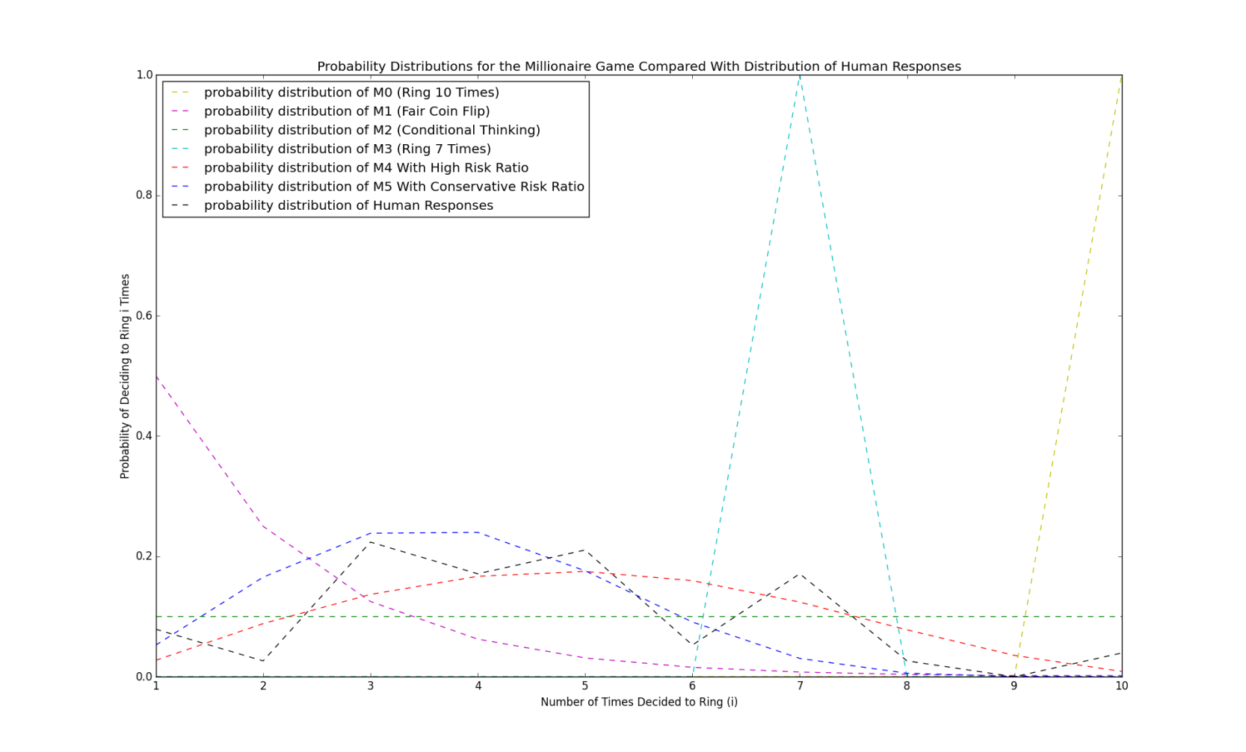

**Figure 1**. Distributions for the millionaire’s game. The conservative risk ratio captures the human clustering at $i$ values from 3 to 5, while with the high risk ratio more successfully captures the $i$ = 7 point, but by coincidence.

Considering the mathematical challenges that the billionaire’s game provided for the conception of a model, the final result performs surprisingly well: on three separate occasions the distribution of the revised billionaire model was almost identical to that of the responses to the billionaire’s game ( $i$ = 3, $i$ = 6, and $i$ = 9). In addition, the $i$ = 7 point was fairly close and the growth and decline in the ranges $i$ = 2 to $i$ = 4 and $i$ = 6 to $i$ = 8, respectively, were captured decently well. The biggest issue with the fit is the local minima at $i$ = 5, which surprises even in retrospect, as I believed the $i$ = 5 point would hold a cluster of people unwilling to bet on a $Z$ result that would have had a probability less than ½ of happening. Another suggestion for further work would be to gather more responses to see if this trend persists. No model fit the overwhelming response- to ring only 4 times- particularly well. The revised billionaire model was closest, achieving its peak only one ring away, albeit both its peak and its result at $i$ = 4 are more than moderately lower than the human response at $i$ = 4. And, of course, the second biggest problem with the fit is the local max at $i$ = 10 (again the “correct” answer).

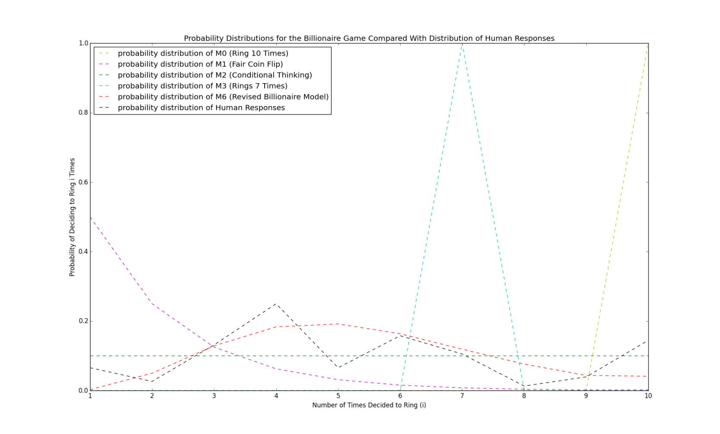

**Figure 2**. The corresponding billionaire’s game. The revised billionaire model captures clustering slightly too late, and is a little too low, yet fits the responses generally well.

There’s a key idea here. Let’s look at M0, which always rings the bell 10 times. In terms of earnings won, this model goes from ranking 7th (out of 9) in the simulations we run for the millionaire to outperforming every model we devised for the billionaire. Of course, this is because 10 is the value that optimizes expected earnings. Why wouldn’t a human do this? And, relatedly, why was the “correct” answer such a model breaking result, in both games? Because subjects can only play the game *once*. Thus, a completely natural thought would be to ensure one wins at least *something*. The most popular answer for the millionaire was 3. For the billionaire it was 4, and this can be attributed to the fact that more money is offered to make the 4th ring than before. The response number then generally *decreases* from then on, similarly to the risk ratio and revised billionaire models, yet the “correct” answers break this trend due to the fact that people calculated this would be the best thing to do over many trials, possibly ignoring the fact that they only get one chance to play the game.

*Performance*

For fun, I wrote code to run simulations of all described models. Illustrative results are shown in Figures 3 and 4 on the next few pages, and Tables 9 and 10 provide typical average earnings for each model in the respective games.

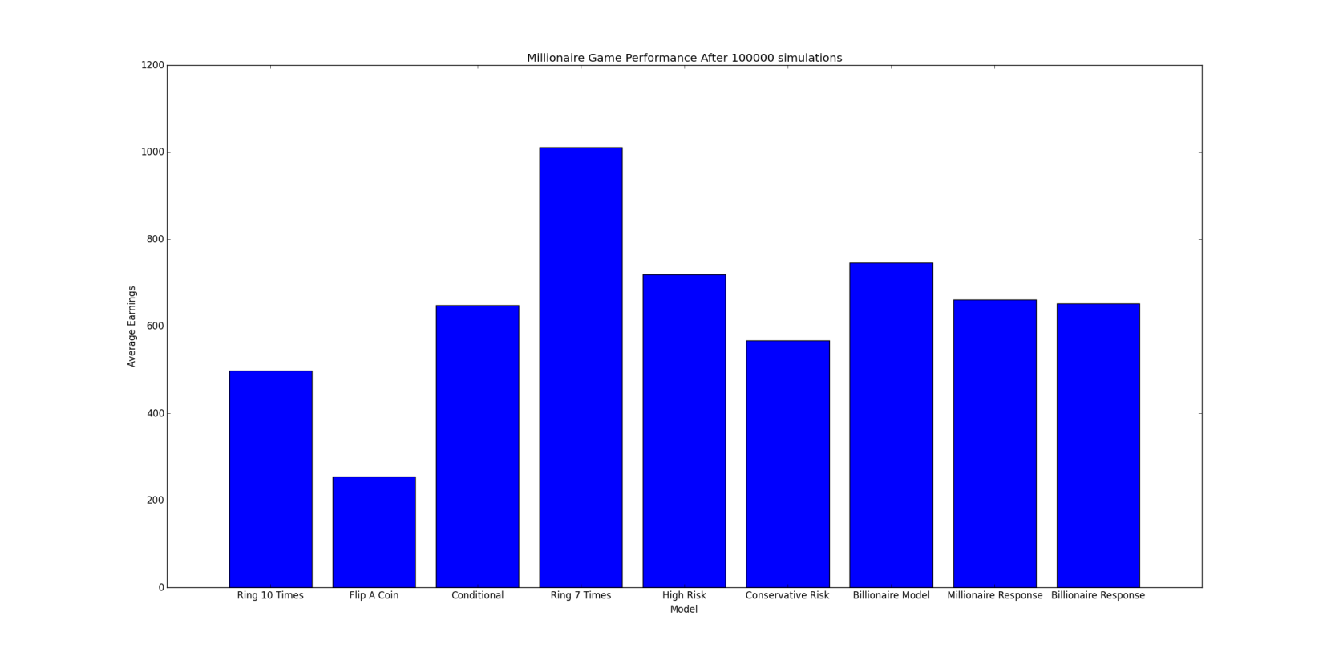

**Figure 3**. Performance of the models for the millionaire’s game. Ringing 7 times (the “correct” answer) performs best.

Table 9**.** Typical average earnings of all described models for the millionaire game, through 100000 simulations (may not be identical to the results depicted in Figure 3, but are nearly the same).

|  |  |
| --- | --- |
| Model | Average Earnings |
| Ring 10 Times | 497.365 |
| Flip a Coin | 255.185 |
| Conditional Thinking | 652.574 |
| Ring 7 Times | 1015.084 |
| High Risk | 724.415 |
| Conservative Risk | 573.495 |
| Billionaire Model | 753.252 |
| Millionaire Response | 661.147 |
| Billionaire Response | 661.177 |

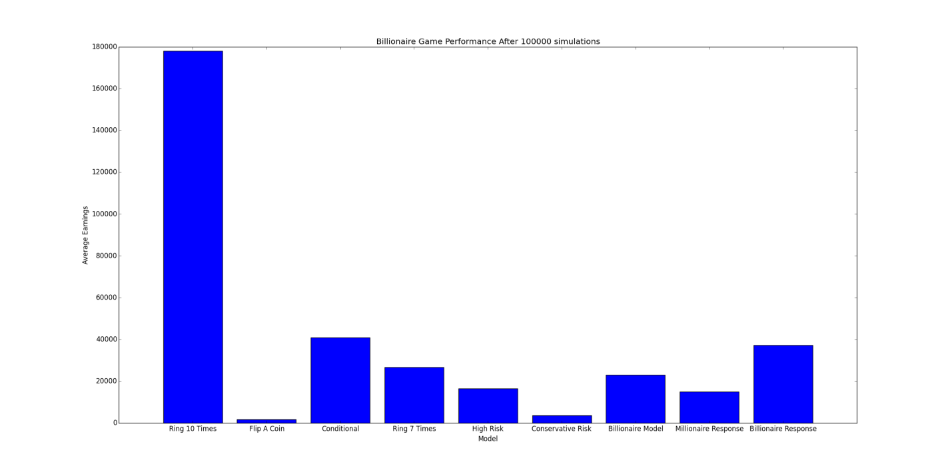

**Figure 4**. Performance of the models for the billionaire’s game. Ringing 10 times (the “correct” answer) performs best (overwhelmingly, due to the lack of diminishing returns).

Table 10**.** Typical average earnings of all described models for the billionaire’s game, through 100000 simulations (may not be identical to the results depicted in Figure 4, but are nearly the same).

|  |  |
| --- | --- |
| Model | Average Earnings |
| Ring 10 Times | 178682.274 |
| Flip a Coin | 1711.491 |
| Conditional Thinking | 40880.623 |
| Ring 7 Times | 26423.334 |
| High Risk | 16770.126 |
| Conservative Risk | 3628.22 |
| Billionaire Model | 22919.989 |
| Millionaire Response | 16063.804 |
| Billionaire Response | 36804.681 |